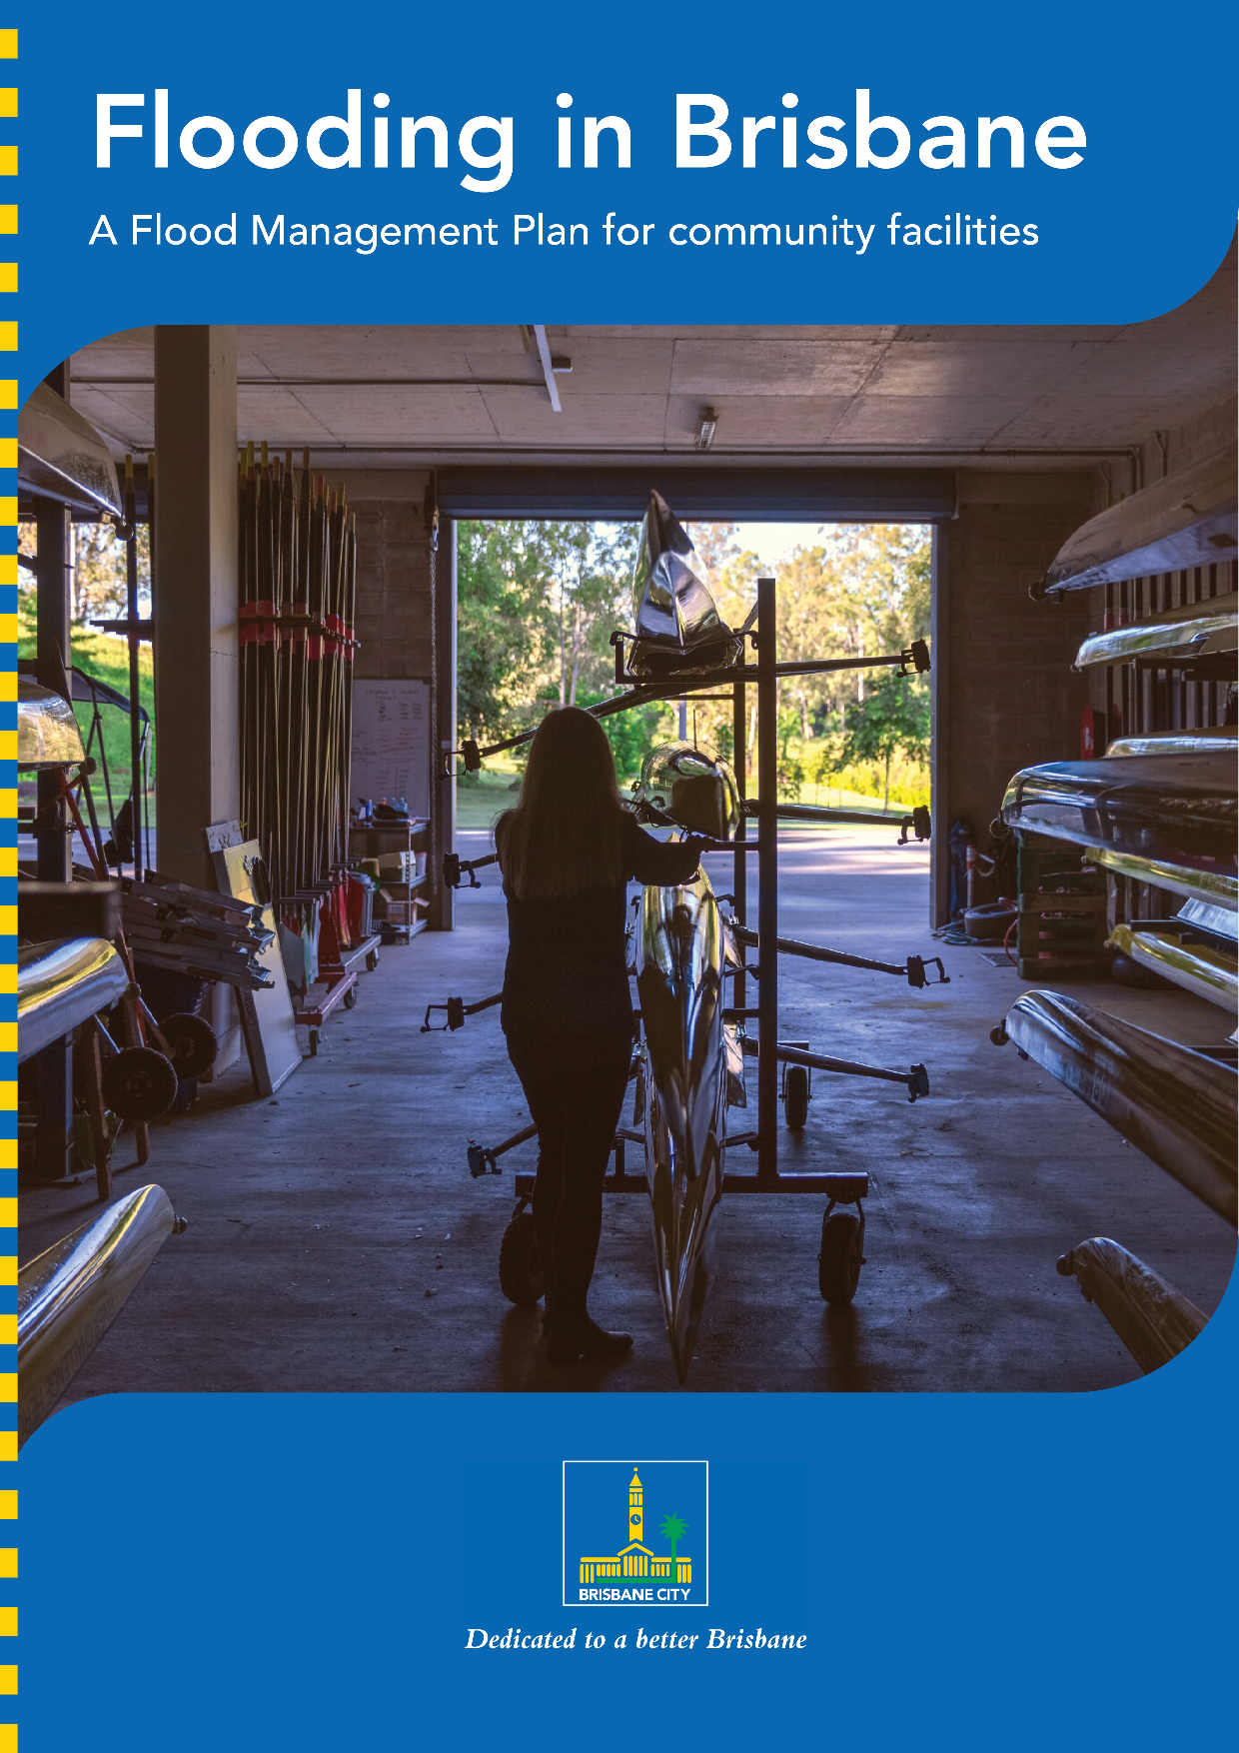

Flooding in Brisbane

Brisbane is a great place to live, work and relax – it’s a safe, vibrant, green and prosperous city, valued for its friendly and optimistic character and enjoyable lifestyle. Brisbane sits on a flood plain which means flooding is possible. Brisbane City Council works to manage and reduce the risks of flooding to ensure our city remains safe and liveable.
This guide will help you ensure that your facility and your community members are safe, resilient and ready.
Flooding can affect community facilities, either directly through water damage to premises, stock and equipment, or indirectly through disruptions to power, communication and transport services.

What is flood resilience for community facilities?
To keep the Brisbane community safe we all need to adapt to and plan for future floods. The goal of flood resilience for community facilities is to develop a considered strategy to reduce the potential impact of flooding on sporting and community organisations.

Purpose

This Flood Management Plan (plan) provides details on how [insert community facility name] will deal with a potential flood event, covering the below three stages:

RESPOND
Flood
RECOVER
Flood
PREPARE
Storm +
Flood

This plan includes three checklists and action plans. It is recommended that you print these checklists and action plans and store in an easily accessible location or post them on the wall of your clubhouse office, and share a digital version in case access to the document is affected during a flood event. This information must be be readily accessible during a flood event.

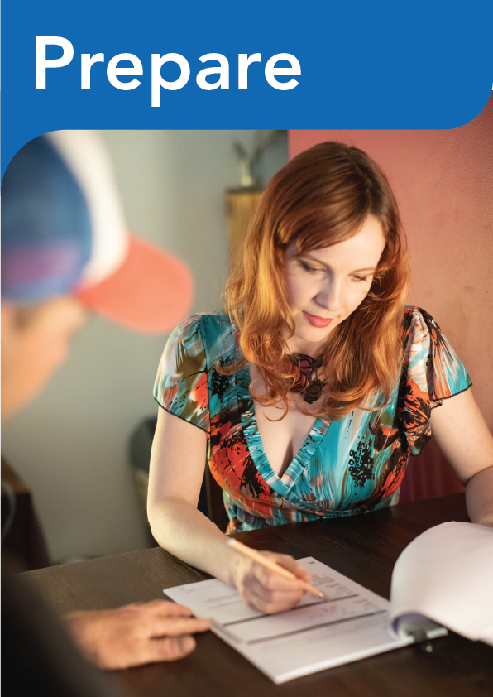

- Have your roof periodically inspected. Older roofs are more prone to damage during storm events. A qualified professional can identify compliance gaps, indications of uplift or movement, corrosion and rot.
- Inspect and repair roof-mounted equipment after severe weather events. Aerials, whirly birds and other roof-mounted equipment can be damaged by wind forces or wind-borne debris. Any ventilation in the roof space can let in rainwater during extreme weather events.
- Keep downpipes and guttering clear.
- Have an emergency kit on hand, including battery-operated
radio, torch and spare batteries.
- Keep a list of emergency numbers handy.
- Tune in to warnings and updates from your local radio and TV
station.
- Store poisons above ground level in case of flash flooding.
- Plan for the safety of any pets or other animals.
- Secure outdoor furniture and any other loose outside items, secure windows and close doors.
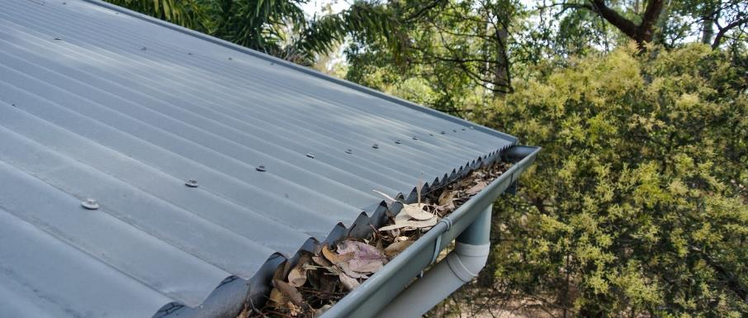

- Know your flood risk (see note below).
- Understand your Rebuild and Recover Flood Resilient Communities Program Recommendations Report.
- Know what type of flooding may affect your community facility.
- Complete this Flood Management Plan.
- Understand your insurance.
- Complete your asset register.
- Plan resilience improvements at your facility.
- Register for Brisbane City Council’s Early Warning Alert Service on brisbane.qld.gov.au search “Severe weather alert”.
- Get more advice on how to be prepared on Council’s website brisbane.qld.gov.au/beprepared.

Know your flood risk
Your facility’s Rebuild and Recover Flood Resilient Communities Recommendations Report will detail your site’s flood risk. If you do not have a Recommendations Report, check Brisbane City Council’s Flood awareness map to see historic flood levels at your site. The flood awareness map is available at brisbane.qld.gov.au search “flood awareness map” Search your address and download your facility’s FloodWise Property Report. This will provide information about the likelihood of flooding and impact.
What type of Flooding is likely to affect your facility?
- Riverine
- Creek
- Overland Flow
- Combination

General Facility Information
Name:
Address:
Operating days:
Operating hours:
Phone:
Number of buildings:
Committee:
Communication method/s used to contact the facility members:
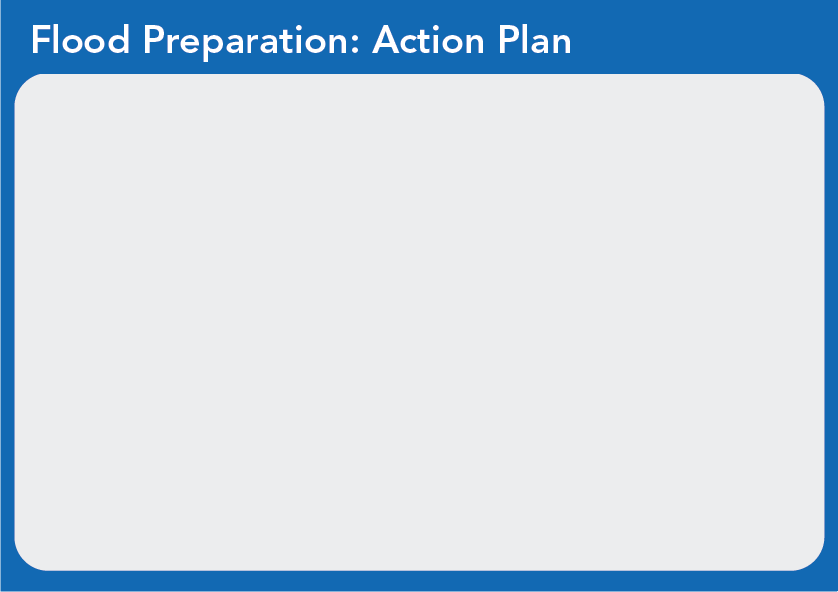

Planned resilience property improvements
Use the below table to note down any repairs, improvements or works around your facility that will help it be more resilient and recover quickly from a potential flood event.
Improvement | Cost | Complete by
E.g. Raising powerpoints and services (HWS, switchboards, aircon vents) to above flood level | Quote: $4,500 | 3 months from now

Insurance details
Insurer | Insurance type | Policy number | Policy coverage | Last review date

Asset register
Item | Est. replacement cost | Description or photo
E.g. Refrigerator | $3,500 | Double-glass-door drinks refrigerator
E.g. Lawnmower | $4,750 | John Deere ride-on zero-turn lawnmower

Flood preparation: Severe Weather Alerts

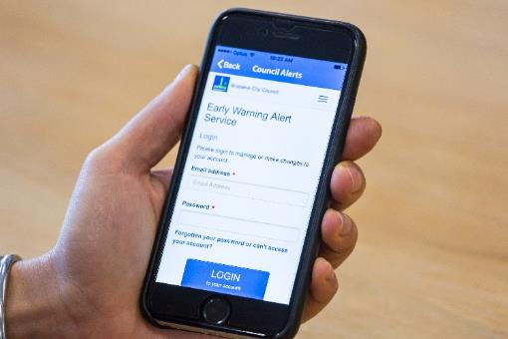
Brisbane City Council’s Severe Weather Alert Service
Registration link: https://ewa.brisbane.qld.gov.au/

Brisbane City Council provides free severe weather alerts for Brisbane residents and visitors. The alert service provides advanced warning for severe weather or other public safety events. This helps prepare and protect people and property.
Council’s Severe Weather Alert service issues alerts only if the Bureau of Meteorology (BoM) issues a severe weather warning for the Brisbane Local Government Area. The alert service is powered by Weatherzone.
You can also download the Weatherzone app to your mobile device to receive push notifications. You will need to have registered a Brisbane Severe Weather Alert subscription to use this service.
You can nominate to receive alerts for up to three Brisbane addresses as well as the location of your mobile device if using the free Weatherzone app. There is no restriction to the number of subscribers per address.

All committee members will need to register for Severe Weather Alert at the Club’s registered address. Some example committee members to register:
- President
- Vice President
- Secretary
- Treasurer
- Onsite Grounds Keeper
- U8s Coach
- U18s Team Manager.

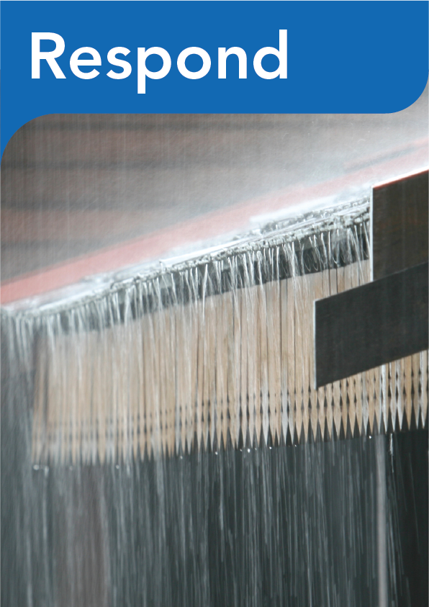

- Decide when you will enact your Flood Management Plan.
- Set up your communication cascade outside operating hours.
- Set up your communication cascade during operating hours.
- Plan the safe routes of travel around your facility.
- Complete your flood management procedures (what needs to happen to respond to a flood?).
- Decide how you will prioritise safety.
- Set up mechanisms to monitor the emerging flood risk.

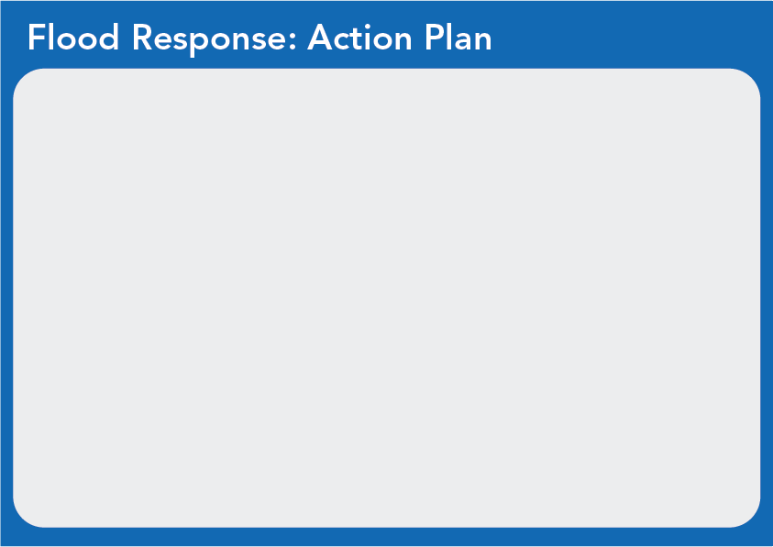
Response communication cascade: out of hours
Responsible party:
Comms
action:
E.g. Registered committee members
E.g. Receive weather alert update
President & secretary
Advise all members and request assistance
Vice president
Contact coaches and managers via SMS
Secretary
Post on social media pages

Response communication cascade: during operating hours
Responsible party:
Comms
action:
All committee members
Receive weather alert update

Safe routes of travel
List of roads that may be potentially closed during a flood event:

INSERT MAP
A property address search http://floodinformation.brisbane.qld.gov.au/ will help you plan these routes.

Flood management procedures
Potential flood response actions
Task/ action required | Responsibility | Equipment Required | Priority
E.g. Turn off all power at the switchboard | Secretary | N/a | High
Move equipment to designated higher-ground storage area | Select committee members, Sue, John and Aditya | N/a | Med-high

Concluding the flood response

The safety of the members and volunteers is the most important consideration of the flood response.
The flood risk must be continually monitored throughout the response phase.
The response phase will conclude when:
- all tasks are completed, or
- the emerging flood risk is assessed as too great to continue.
When the respond phase concludes, it is critical to ensure that everyone who assisted is accounted for before leaving site and that a safe route of exit has been confirmed.

General flood safety
- Don't enter floodwater
- Keep informed about weather patterns and weather forecasts and act quickly on any advice
- Stay away from rivers, creeks and drains
- Never try to drive, ride or walk through floodwater.

Find information about flood safety and preparation at brisbane.qld.gov.au/ beprepared

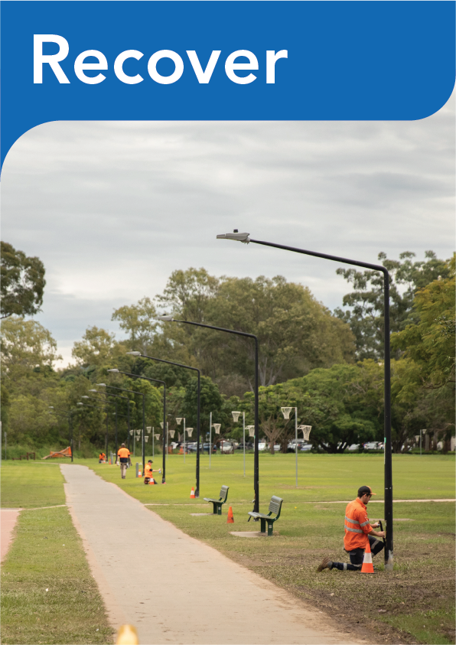

Recovery is the return to pre-flood key activities. Performing key activities as soon as it is safe to do so after a flood is a primary focus.

- Identify and mitigate potential risks to health and safety.
- Refocus efforts towards recovery.
- Use the clean-up and recovery resources available.
- Assess impact to key activities.
- Document damage against asset register.
- Contact insurer.
- Assess current financial position.
- Contact relevant Council’s Sport and Recreation Officer.
- Keep members informed.
- Investigate what financial assistance may be available.
- Prioritise recovery to return to key activities.
- Implement further flood resilience measures.
- Record lessons learnt in ‘Flood Recovery: Action Plan’.
- Review Flood Management Plan.
- Determine safe, environmental and effective ways to dispose of
waste and damaged goods.

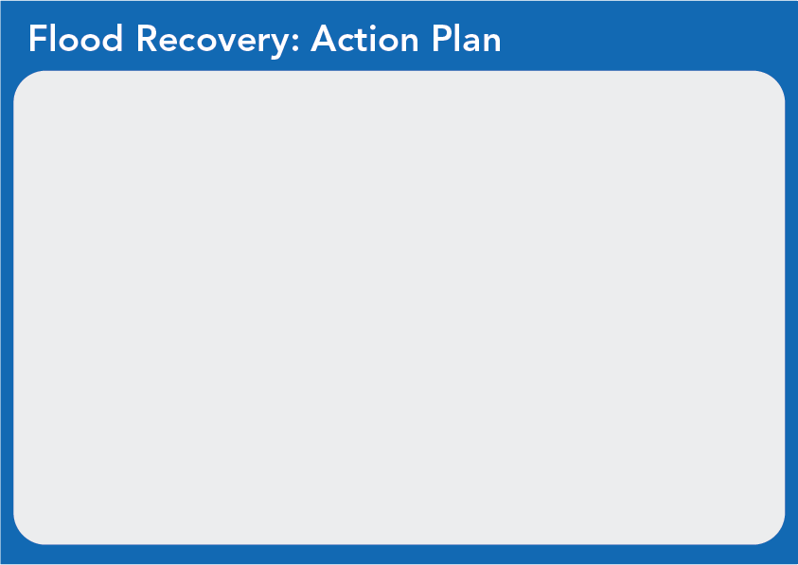
Key recovery contacts
Type | Organisation | Name | Phone | Email | Notes
Insurance
Council Sport and Recreation Officer
Emergency Electrician
Emergency Plumber
Structural Engineer?
Phone/ internet provider
Electricity Provider
Gas Provider
Water & sewerage
Solicitor
Accountant

Insurance Claims
What Policies have you claimed for?
Insurance Company | Policy No. | Details of claim | Follow up Actions (dated)
E.g. Allianz | 012345 | Replacement of damaged goods up to $10,000 | Contact insurer within a two days of the flood event.

Resilience Works
Are there any things you need to consider when cleaning up to protect your flood resilient works and products?
Item | Consideration
E.g. All doors have been replaced with Solid Core Doors | Do not remove doors during clean up
Post-flood turf recovery | Aerate turf with a tractor or manually as soon as it is safe to do so. Remove silt or mud in the following days after the flood has receded.
Maintain and review
Complete this section after a flood to review lessons learnt
What worked in our Flood Management Plan? | E.g. Quick communication and action in the event of a potential flood.  Moving sports equipment to upstairs of clubhouse before flood event.
What did not work in our Flood Management Plan? | Club volunteers responsible for enacting plan were also flood affected at home and unable to visit and enact club FMP.
How can we improve our Flood Management Plan? | Always ensure responsible volunteers in the FMP have a lower personal risk of flooding than the club site itself, while still being relatively close to the facility.
How can we continue to build our flood resilience? | Replace carpets in clubhouse office with hardwood, tiles or polished concrete.

Flood recovery safety

When recovering from a flood event, follow these rules:
- Wait until floodwater has subsided.
- Always use personal protective equipment (enclosed footwear, gloves and suitable clothing) during the clean-up, particularly when contact with floodwater and mud is unavoidable.
- Stay away from switchboards if they are damaged by water.
- Be aware of asbestos-containing materials among the debris from flooding
- Be aware of potential chemical spills.
- Have a licensed electrical contractor check any electrical appliances or equipment you suspect has been submerged or damaged.
- Do not use gas appliances until these have been checked.
- Be aware of items that may be contaminated by sewage.
- Ensure appropriate first aid and clean drinking water is available.
- Ensure anyone assisting with the clean-up is reporting health and safety concerns.

For more advice on public health during a disaster and recovery, visit www.qld.gov.au/community/disasters-emergencies/disasters/phys-health-wellbeing

In partnership with

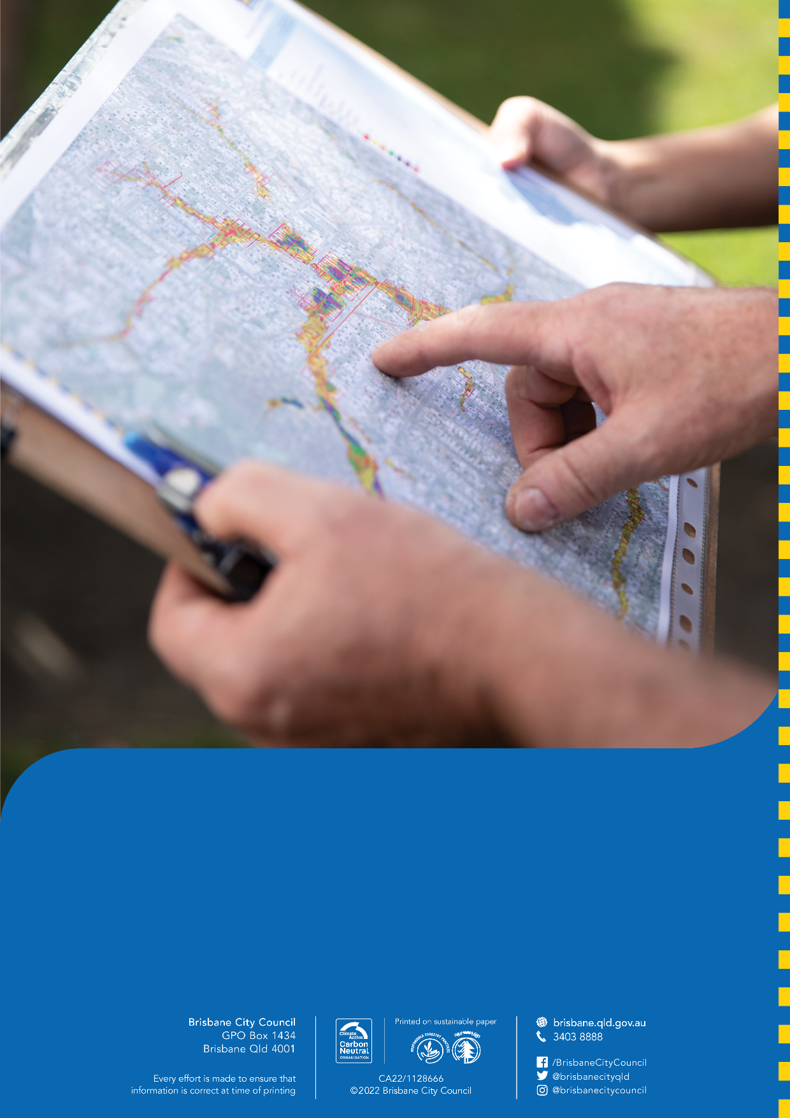
Scan the QR code above to view and download a digital version of this plan.
For more information, visit brisbane.qld.gov.au and search ‘Flooding in Brisbane’.

